Preparing priority for the new year 2018

Between now and the end of december you must complete this procedure:

Purpose: Document numbers in the system are determined on a yearly basis with the prefix number for the current year. For example:
Document | Year | Prefix | Starting Number | Resulting Number
Sales Orders | 2017 | SO17 | 1 | SO170001
Purchase Order | 2017 | PO17 | 1 | PO170001
Sales Orders | 2017 | SO17 | 1 | SO170001
Purchase Order | 2017 | PO17 | 1 | PO170001

You cannot record any transactions for the next calendar year until you have told the system what the numeration should be. This enables you to change the numeration from year to year.

Users on Version 13 and earlier, please follow the instructions on page 2
Users on Version 14 or higher, please follow the instructions on page 6

V13 and Earlier Users Procedure:

- Initialise the document numbers by running the Open Numeration Templates program:

  - Go to ‘Financials > Maintenance of Financials > Auxiliary Programs > Open Numeration Templates’.
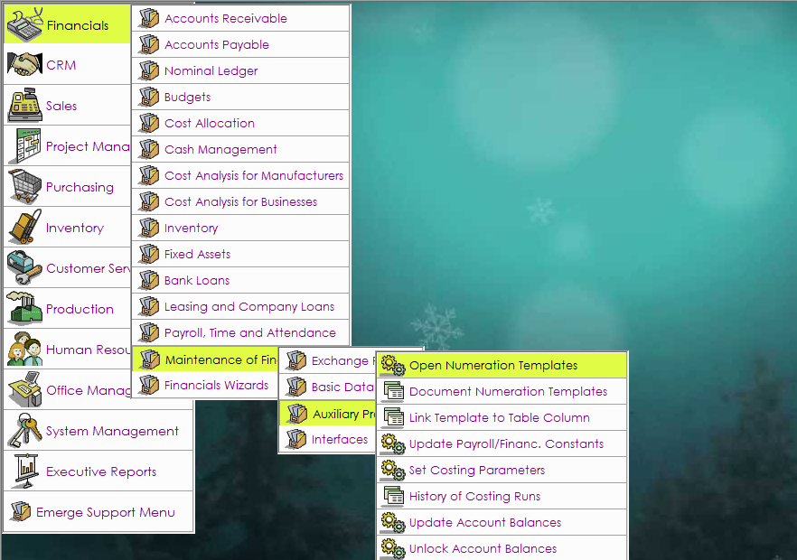

  - Set ‘Year =’ to ‘2018’.

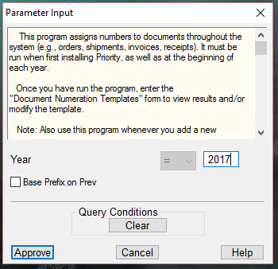
This option is not available in version 13
and earlier

  - Click ‘Approve’ to continue.

- Open Document Numeration Templates form.
  - Financials > Maintenance of Financials > Auxiliary Programs > Document Numeration Templates
You will see listed the templates for all documents in the system
Double click the date heading to order by newest first!

- The default value assigned by the system for 2018 is 18. After running the Open Numeration Templates program, you should change the prefixes from the defaults set by the program. For example, Purchase Orders are numbered as A18. To change this, you should go to the Prefix column and change the value to PO18 or an identification of your choice in the form.

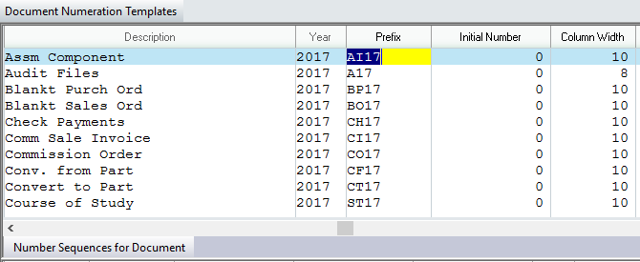

Increase the column width to ensure that you can record enough documents. For example, if your prefix is PO18 and your column width is 8, then you will only be able to record 9,999 documents (width of 8 = 4 spaces for the prefix, 4 spaces for the number). If the maximum column width for particular documents is insufficient for your requirements, please contact the support desk.

- Decide and set number continuity:
  - The starting value for all documents is reset to 0 for the New Year. Therefore, documents will start at PO170001. If you want this option then no further action is required.
  - If you wish to continue your numbering from 2017 you will need to define the number, you wish to start with in the column headed Initial Number. E.g. If the last Purchase Order for 2017 was PO1709825, you would change the Initial Number to read “9825”, which will make the first Purchase Order of 2017 PO1709826.
NOTE – If you choose to continue your numbering, this step must be carried out after all 2017 documents have been entered and before you start recording 2018 documents.
- WARNING:
  - Once you record even a single document of a particular type in the New Year, you will no longer be able to change the numbering of that document type for the current year. Therefore, check the numberings carefully before beginning to record documents. For example:
    - Make sure there are enough continuous numbers available and that similar documents do not begin with the same prefix.
    - That the total number of characters is enough to include the prefix.
    - The starting number and the estimated amount of documents are sufficient for your needs.

Should you require any additional information please contact Customer Support on:
0845 230 6740

V14 or Higher Users Procedure:

- Initialise the document numbers by running the Open Numeration Templates program:

  - Go to ‘Financials > Maintenance of Financials > Auxiliary Programs > Open Numeration Templates’.
- You can base the new Numeration Templates on those configured for the previous year by selecting ‘Base Prefix on Prev’. This will automatically create the new Numeration Templates based on those configured for the previous (current) year. If you do not select this option, the system will default to the standard settings. Each document has its own prefix code pre-defined, e.g. “Cheque Payments” would be CH18. Make sure you change the year to 2018.

  - Click ‘Approve’ to continue.

  - The program will now create the new Numeration Templates. This may take a few moments. Once complete, a message will displayed confirming the program has completed successfully.

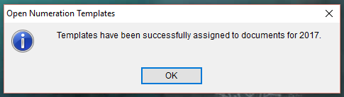

- Open the Document Numeration Templates form.
  - Go to ‘Financials > Maintenance of Financials > Auxiliary Programs > Document Numeration Templates’

- You will see listed the templates for all documents in the system.

- The default value assigned by the system for 2018 is 18. The prefix will have been set according to your earlier choice in section 2 above. If you wish to amend any of these you can change the prefixes at any time up until the first entry of the New Year is made. To change this, go to the Prefix column and change the value to an identification of your choice in the form.
- Increase the column width to ensure that you can record enough documents. For example if your prefix is PO18 and your column width is 8, you will only be able to record 9,999 documents (width of 8 = 4 spaces for the prefix, 4 spaces for the number). If the maximum column width for particular documents is insufficient for your requirements, please contact the support desk.
- Decide and set number continuity:
  - The starting value for all documents is reset to 0 for the New Year. Therefore documents will start at PO180001. If you want this option then no further action required.
  - If you wish to continue your numbering from 2017 you will need to define the number, you wish to start with in the column headed Initial Number. E.g. if the last Purchase Order for 2017 was PO179825, you would change the Initial Number to read 9825, which will make the first Purchase Order of 2018 PO189826.
NOTE – If you choose to continue your numbering, this step must be carried out after all 2017 documents have been entered and before you start recording 2018 documents.

- WARNING:
  - Once you record a document of a particular type in the New Year, you will no longer be able to change the numbering of that document type for the current year. Therefore, check the numberings carefully before beginning to record documents. For example:
    - Make sure there are enough continuous numbers available and that similar documents do not begin with the same prefix.
    - The total number of characters for each document type is sufficient to include the prefix.
    - The starting number and the estimated amount of documents are sufficient for your needs.

Should you require any additional information please contact Customer Support on:
0845 230 6740

